Задание.

Номер варианта определяется по двум последним цифрам зачетной книжки. В соответствии с номером варианта рассчитать в схеме токи в каждой ветви. Ответ записать в форме *I*=*Im*sin(*ωt+φi*). Построить векторную диаграмму токов и графически определить суммарный вектор общего тока.

|  |  |  |  |  |  |  |  |  |  |  |  |  |
| --- | --- | --- | --- | --- | --- | --- | --- | --- | --- | --- | --- | --- |
| Вар. | Рис. | L1 | L2 | L3 | C1 | C2 | C3 | R1 | R2 | R3 | f | *u*(*t*) |
| мГн | | | мкФ | | | Ом | | | Гц | В |
|  | 2.12 | - | 63,8 | - | 106 | ∞ | - | - | - | 10 | 50 | 100 sin (ωt +60°) |
|  | 2.9 | 21,2 | 0 | - | - | 132,5 | - | - | - | 25 | 60 | 70,5 sin ωt |
|  | 2.1 | - | 34,7 | - | - | ∞ | 80,3 | 17 | - | - | 55 | 80 sin (ωt +45°) |
|  | 2.7 | 13,6 | - | 109,2 | 32,5 | - | 94,6 | - | 65 | - | 70 | 141 cos (ωt -90°) |
|  | 2.5 | - | - |  | 50 | - | 184 | - | 65 | - | 50 | 141 cos(ωt +345°) |
|  | 2.11 | - | 21,2 | 24,8 | - | - | 35,5 | 17 | - | - | 90 | 80 sin (ωt +40°) |
|  | 2.9 | 12,7 | 47,8 | - | - | 31,9 | - | - | - | 25 | 100 | 70,5 sin (ωt +20°) |
|  | 2.3 | 100,5 | - | 0 | 88,5 | - | 132,5 | - | 25 | - | 60 | 70,5 sin (ωt -13°) |
|  | 2.11 | - | 83,8 | 0 | - | 15,8 | 29,5 | 17 | - | - | 150 | 113sin (ωt +338°) |
|  | 2.3 | 20,8 | - | 52,7 | 15,1 | - | 64,6 | - | 65 | - | 130 | 100 sin (ωt -35°) |
|  | 2.4 | 0 | 250 | - | 31,8 | 66 | - | - | - | 100 | 50 | 141 cos(ωt +270°) |
|  | 2.13 | - | 477 | 125 | - | 4 | 33 | 100 | - | - | 100 | 63,5 sin (ωt -56°) |
|  | 2.5 | - | - | 159 | 15,9 | - | ∞ | - | 100 | - | 100 | 80 cos(ωt -135°) |
|  | 2.9 | 100 | 25 | - | - | 8 | - | - | - | 100 | 159 | 80 sin (ωt -50°) |
|  | 2.14 | - | 136 | - | - | 18,2 | 9,1 | 100 | - | - | 175 | 56,6cos(ωt+235°) |
|  | 2.8 | 120 | - | 0 | 16 | - | 8 | - | 100 | - | 200 | 169sin (ωt +180°) |
|  | 2.6 | 24 | - | - | 12,7 | 5,5 | - | - | - | 10 | 500 | 200sin (ωt +45°) |
|  | 2.10 | 0 | 80 | 145 | ∞ | - | 44,5 | 60 | - | - | 120 | 282sin(ωt-180°) |

|  |  |  |  |  |  |  |  |  |  |  |  |  |
| --- | --- | --- | --- | --- | --- | --- | --- | --- | --- | --- | --- | --- |
| Вар. | Рис. | L1 | L2 | L3 | C1 | C2 | C3 | R1 | R2 | R3 | f | *u*(*t*) |
| мГн | | | мкФ | | | Ом | | | Гц | В |
|  | 2.2 | - | 0 | 1000 | 20 | ∞ | 8 | - | 25 | - | 40 | 566 cos(ωt +270°) |
|  | 2.15 | 80 | 90 | 0 | 10 | 5 | ∞ | - | - | 70 | 160 | 141 cos(ωt -30°) |
|  | 2.12 | - | 63,8 | - | 106 | ∞ | - | - | - | 10 | 50 | 99 sin (ωt +20°) |
|  | 2.9 | 12,7 | 31,8 | - | - | 39,8 | - | - | - | 25 | 100 | 70,5 cos(ωt +270°) |
|  | 2.1 | - | 17,35 | - | - | ∞ | 40,15 | 17 | - | - | 110 | 113 sin ωt |
|  | 2.7 | 13,6 | - | 54,6 | 32,5 | - | ∞ | - | 65 | - | 70 | 141 sin ωt |
|  | 2.5 | - | - | 26,3 | 12,5 | - | 88,4 | - | 65 | - | 200 | 200 cos ωt |
|  | 2.11 | - | 10,6 | 24,8 | - | - | 13,8 | 17 | - | - | 180 | 62 sin (ωt+326°) |
|  | 2.9 | 12,7 | 8 | - | - | 63,8 | - | - | - | 25 | 100 | 70,5 sin (ωt +20°) |
|  | 2.3 | 402 | - | 0 | 354 | - | 530 | - | 25 | - | 15 | 70,5 sin (ωt +257°) |
|  | 2.11 | - | 41,9 | 19,13 | - | 7,9 | 7,4 | 17 | - | - | 300 | 113 sin (ωt -22°) |
|  | 2.3 | 10,4 | - | 26,35 | 7,55 | - | 32,3 | - | 65 | - | 260 | 56,4 sin(ωt-40°) |
|  | 2.4 | 1600 | 250 | - | 5,3 | 66 | - | - | - | 100 | 50 | 84,6 sin(ωt-10°) |
|  | 2.13 | - | 1600 | 250 | - | 5,3 | 66 | 100 | - | - | 50 | 282sin (ωt -135°) |
|  | 2.5 | - | - | 318 | 15,9 | - | 15,9 | - | 100 | - | 100 | 84,6 cos(ωt+240°) |
|  | 2.9 | 159 | 39,8 | - | - | 12,7 | - | - | - | 100 | 100 | 46,2 sin ωt |
|  | 2.14 | - | 68 | - | - | 9,1 | 4,55 | 100 | - | - | 350 | 169 cos(ωt -90°) |
|  | 2.8 | 60 | - | 0 | 8 | - | 4 | - | 100 | - | 400 | 169sin (ωt +180°) |
|  | 2.6 | 16 | - | - | ∞ | 5,5 | - | - | - | 10 | 500 | 56,4cos(ωt-147°) |
|  | 2.10 | 0 | 320 | 580 | ∞ | - | 178 | 60 | - | - | 30 | 200sin(ωt+5°) |
|  | 2.2 | - | 49,75 | 500 | 10 | 79,6 | 4 | - | 25 | - | 80 | 566 cos(ωt -90°) |
|  | 2.15 | 320 | 360 | 0 | 40 | 20 | ∞ | - | - | 70 | 40 | 141sin (ωt -300°) |
|  | 2.12 | - | 127,6 | - | 106 | 159 | - | - | - | 10 | 50 | 99sin (ωt-340°) |

|  |  |  |  |  |  |  |  |  |  |  |  |  |
| --- | --- | --- | --- | --- | --- | --- | --- | --- | --- | --- | --- | --- |
| Вар. | Рис. | L1 | L2 | L3 | C1 | C2 | C3 | R1 | R2 | R3 | f | *u*(*t*) |
| мГн | | | мкФ | | | Ом | | | Гц | В |
|  | 2.9 | 21,2 | 39,8 | - | - | 75,6 | - | - | - | 25 | 60 | 70,5 cos(ωt -90°) |
|  | 2.1 | - | 34,7 | - | - | ∞ | 80,3 | 17 | - | - | 55 | 113,1 sin ωt |
|  | 2.7 | 6,8 | - | 54,6 | 16,25 | - | 47,3 | - | 65 | - | 140 | 141 cos(ωt +270°) |
|  | 2.5 | - | - | 26,3 | 12,5 | - | 88,4 | - | 65 | - | 200 | 141 sin (ωt +75°) |
|  | 2.11 | - | 21,2 | 49,6 | - | - | 27,6 | 17 | - | - | 90 | 62cos(ωt-124°) |
|  | 2.9 | 6,35 | 4 | - | - | 31,9 | - | - | - | 25 | 200 | 70,5 sin (ωt +20°) |
|  | 2.3 | 402 | - | 228 | 354 | - | 265 | - | 25 | - | 15 | 70,5 cos(ωt -130°) |
|  | 2.11 | - | 41,9 | 0 | - | 7,9 | 14,75 | 17 | - | - | 300 | 60sin (ωt +315°) |
|  | 2.3 | 20,8 | - | 52,7 | 15,1 | - | 64,6 | - | 65 | - | 130 | 60cos(ωt+90°) |
|  | 2.4 | 1060 | 413 | - | 17,6 | 110 | - | - | - | 100 | 30 | 141 cos(ωt -90°) |
|  | 2.13 | - | 662 | 103 | - | 2,21 | 27,6 | 106 | - | - | 120 | 96,4 sin(ωt+201°) |
|  | 2.5 | - | - | 318 | 31,8 | - | ∞ | - | 100 | - | 50 | 179 cos(ωt -90°) |
|  | 2.9 | 100 | 25 | - | - | 8 | - | - | - | 100 | 159 | 169sin (ωt +90°) |
|  | 2.14 | - | 136 | - | - | 18,2 | 9,1 | 100 | - | - | 175 | 100cos(ωt+315°) |
|  | 2.8 | 60 | - | 40 | 8 | - | 2 | - | 100 | - | 400 | 169 sin(ωt -180°) |
|  | 2.6 | 48 | - | - | 25,4 | 11 | - | - | - | 10 | 250 | 282cos(ωt+90°) |
|  | 2.10 | 0 | 160 | 290 | ∞ | - | 89 | 60 | - | - | 60 | 705cos(ωt-37°) |
|  | 2.2 | - | 0 | 500 | 10 | ∞ | 4 | - | 25 | - | 80 | 620sin (ωt +54°) |
|  | 2.15 | 80 | 90 | 69,75 | 10 | 5 | 14,22 | - | - | 70 | 160 | 141sin (ωt -300°) |
|  | 2.12 | - | 53 | - | 88,4 | ∞ | - | - | - | 10 | 60 | 99 cos (ωt+290°) |
|  | 2.9 | 21,2 | 0 | - | - | 132,5 | - | - | - | 25 | 60 | 56sin (ωt -60°) |
|  | 2.1 | - | 69,4 | - | - | 240,6 | 80,3 | 17 | - | - | 55 | 111,3 cos(ωt -90°) |
|  | 2.7 | 6,8 | - | 27,3 | 16,25 | - | ∞ | - | 65 | - | 140 | 141 sin ωt |

|  |  |  |  |  |  |  |  |  |  |  |  |  |
| --- | --- | --- | --- | --- | --- | --- | --- | --- | --- | --- | --- | --- |
| Вар. | Рис. | L1 | L2 | L3 | C1 | C2 | C3 | R1 | R2 | R3 | f | *u*(*t*) |
| мГн | | | мкФ | | | Ом | | | Гц | В |
|  | 2.5 | - | - | 63,5 | 25 | - | 100 | - | 65 | - | 100 | 141 cos(ωt -15°) |
|  | 2.11 | - | 23,7 | 27,9 | - | - | 39,9 | 17 | - | - | 80 | 84,6cos(ωt-133°) |
|  | 2.9 | 12,7 | 47,8 | - | - | 31,9 | - | - | - | 25 | 100 | 66,5 sin ωt |
|  | 2.3 | 100,5 | - | 56,9 | 88,5 | - | 66,25 | - | 25 | - | 60 | 70,5 sin (ωt-13°) |
|  | 2.11 | - | 167,6 | 76,52 | - | 31,6 | 29,5 | 17 | - | - | 75 | 113 cos(ωt -112°) |
|  | 2.3 | 20,8 | - | 29,4 | 15,1 | - | ∞ | - | 65 | - | 130 | 89,5 cos(ωt -150°) |
|  | 2.4 | 159 | 250 | - | 21,2 | 66 | - | - | - | 100 | 50 | 244 cos ωt |
|  | 2.13 | - | 318 | 250 | - | 15,9 | 66 | 100 |  | - | 50 | 40 sin(ωt+5°) |
|  | 2.5 | - | - | 636 | 31,8 | - | 31,8 | - | 100 | - | 50 | 84,6 sin(ωt-100°) |
|  | 2.9 | 50 | 12,5 | - | - | 4 | - | - | - | 100 | 318 | 705 sin(ωt-53°) |
|  | 2.14 | - | 68 | - | - | 9,1 | 4,55 | 100 | - | - | 350 | 705 cos(ωt+90°) |
|  | 2.8 | 120 | - | 80 | 16 | - | 4 | - | 100 | - | 200 | 169 sin(ωt -180°) |
|  | 2.6 | 16 | - | - | ∞ | 5,5 | - | - | - | 10 | 500 | 282 cos (ωt-90°) |
|  | 2.10 | 318,4 | 320 | 580 | 88,4 | - | 178 | 60 | - | - | 30 | 282 sin (ωt-40°) |
|  | 2.2 | - | 199 | 2000 | 40 | 318,4 | 16 | - | 25 | - | 20 | 566sin ωt |
|  | 2.15 | 320 | 360 | 279 | 40 | 20 | 56,88 | - | - | 70 | 40 | 141cos (ωt +330°) |
|  | 2.12 | - | 47,8 | - | 53 | 159 | - | - | - | 10 | 100 | 99 cos (ωt-70°) |
|  | 2.9 | 8,46 | 0 | - | - | 53,2 | - | - | - | 25 | 150 | 70,5 cos (ωt-90°) |
|  | 2.1 | - | 34,7 | - | - | 120,3 | 40,15 | 17 | - | - | 110 | 113 cos(ωt -90°) |
|  | 2.7 | 13,6 | - | 54,6 | 32,5 | - | ∞ | - | 65 | - | 70 | 100 sin (ωt+45°) |
|  | 2.5 | - | - | 38,2 | 12,5 | - | 33,2 | - | 65 | - | 200 | 141sin (ωt -285°) |
|  | 2.11 | - | 21,2 | 24,8 | - | - | 35,5 | 17 | - | - | 90 | 112,8sin(ωt-95°) |
|  | 2.9 | 6,35 | 23,9 | - | - | 15,9 | - | - | - | 25 | 200 | 70 cos(ωt -70°) |

|  |  |  |  |  |  |  |  |  |  |  |  |  |
| --- | --- | --- | --- | --- | --- | --- | --- | --- | --- | --- | --- | --- |
| Вар. | Рис. | L1 | L2 | L3 | C1 | C2 | C3 | R1 | R2 | R3 | f | *u*(*t*) |
| мГн | | | мкФ | | | Ом | | | Гц | В |
|  | 2.3 | 201 | - | 0 | 177 | - | 265 | - | 25 | - | 30 | 70,5 sin (ωt-103°) |
|  | 2.11 | - | 167,6 | 0 | - | 31,6 | 59 | 17 | - | - | 75 | 60 sin(ωt -34°) |
|  | 2.3 | 10,4 | - | 14,7 | 7,55 | - | ∞ | - | 65 | - | 260 | 73 sin ωt |
|  | 2.4 | 318 | 125 | - | 5,3 | 33 | - | - | - | 100 | 100 | 56,6 sin(ωt-35°) |
|  | 2.13 | - | 1600 | 250 | - | 5,3 | 66 | 100 | - | - | 50 | 282 sin (ωt-50°) |
|  | 2.5 | - | - | 159 | 15,9 | - | ∞ | - | 100 | - | 100 | 282cos(ωt-65°) |
|  | 2.9 | 159 | 39,8 | - | - | 12,7 | - | - | - | 100 | 100 | 56,4 sin(ωt-40°) |
|  | 2.14 | - | 238 | - | - | 31,8 | 15,9 | 100 | - | - | 100 | 83,5 sin ωt |
|  | 2.8 | 60 | - | 40 | 8 | - | 2 | - | 100 | - | 400 | 169sin (ωt -180°) |
|  | 2.6 | 32 | - | - | ∞ | 11 | - | - | - | 10 | 250 | 169 cos ωt |
|  | 2.10 | 79,6 | 80 | 145 | 22,1 | - | 44,5 | 60 | - | - | 120 | 325 sin(ωt-30°) |
|  | 2.2 | - | 0 | 2000 | 40 | ∞ | 16 | - | 25 | - | 20 | 440sin (ωt -316°) |
|  | 2.15 | 160 | 180 | 0 | 20 | 10 | ∞ | - | - | 70 | 80 | 141sin (ωt +60°) |

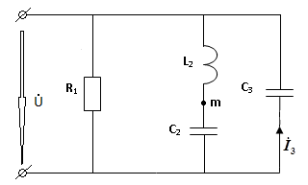 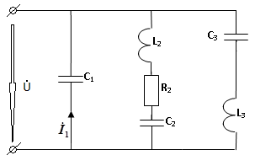

Рис. 2.1 Рис. 2.2

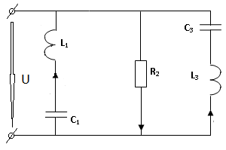 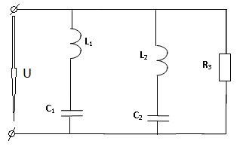

Рис. 2.3 Рис. 2.4

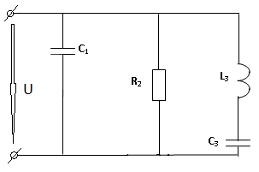 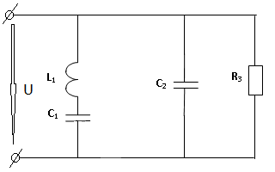

Рис. 2.5 Рис. 2.6

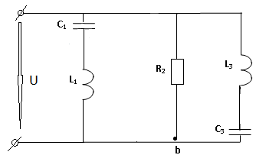 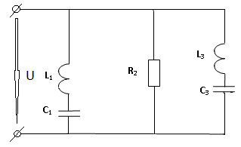

Рис. 2.7 Рис. 2.8

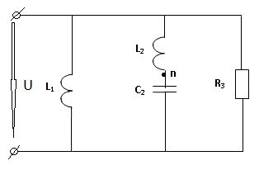 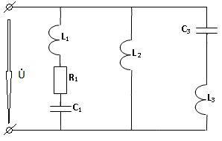

Рис. 2.9 Рис. 2.10

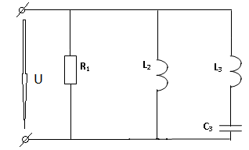 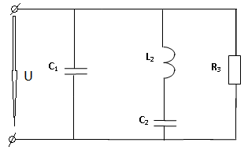

Рис. 2.11 Рис. 2.12

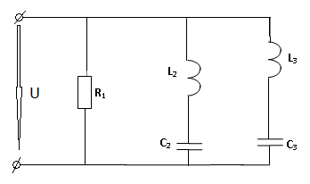 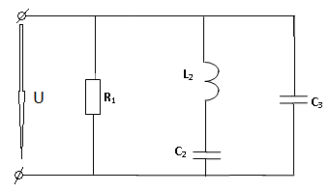

Рис. 2.13 Рис. 2.14

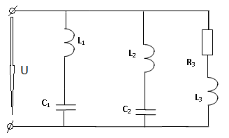

Рис. 2.15